JAVA ASSIGNMENT-04 (12/11/2018)

1)Write a java program to find the given number is even or odd by using method as static

class EvenOrOdd
{
static void getEvenOrOdd(int a)
{
if(a%2==0)
{
System.out.println(a+" is even");
}
else
{
System.out.println(a+" is odd");
}
}
}
class TestEvenOrOdd
{
public static void main(String args[])
{
EvenOrOdd.getEvenOrOdd(9);
}
}

Output :
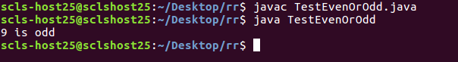

2)Write a java program to find the given number is even or odd by using method as static to return the result.

class EvenOdd
{
static int getEvenOdd(int a)
{
return a;
}
}
class TestEvenOddreturn
{
public static void main(String args[])
{
int c=EvenOdd.getEvenOdd(7);
if(c%2==0)
{
System.out.println(c+"is even");
}
else
{
System.out.println(c+" is odd");
}
}
}

Output:

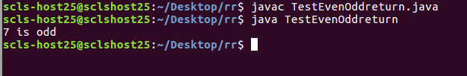

3)Write a java program to find the given number is prime or not.

class Prime
{
static void primeNot(int n)
{
int divisioncount=0;

for(int i=1;i<=n;i++)
{
if(n%i==0)
{
divisioncount=divisioncount+1;
}
}
if(divisioncount==2)
{
System.out.println(n+"is Prime Number");
}
else
{
System.out.println(n+"is Not Prime Number");
}
}
}
class PrimeOrNot
{
public static void main(String args[])
{
Prime.primeNot(8);
}
}

Output:
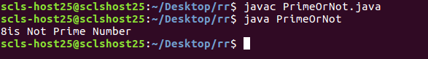

4)Write a java program to find the even and odd numbers between 10&29.

class FEvenOdd
{
static void evenOdd()
{
for(int i=10;i<=29;i++)
{
if(i%2==0)
{
System.out.println(i+" is Even Number");
}
else
{
System.out.println(i+"is Odd Number");
}
}

}
}
class FindEvenOdd
{
public static void main(String args[])
{
FEvenOdd.evenOdd();
}
}
Output:
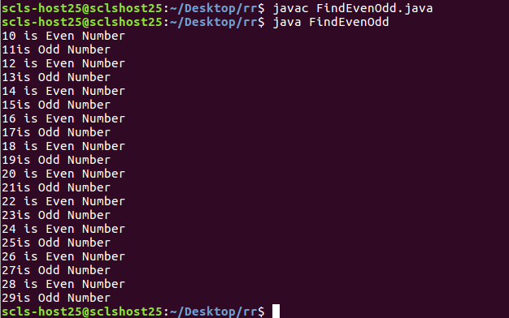

5)Wirte a java program to find the multiples of a given number from 200-300.

class Multiples
{
int n;
void getNum(int a)
{
n=a;
for(int i=200;i<=300;i++)
{
if(i%a==0)
{
System.out.println(i+"is multiple of"+ a);
}

}
}
}

class TestMultiple
{
public static void main(String args[])
{
Multiples obj=new Multiples();
obj.getNum(5);
}
}
Output:
